A497-AM,N-NW-Washington-Columbia River-Granite Mortar-Tsagaglalal-She Who Watches-pre 1800

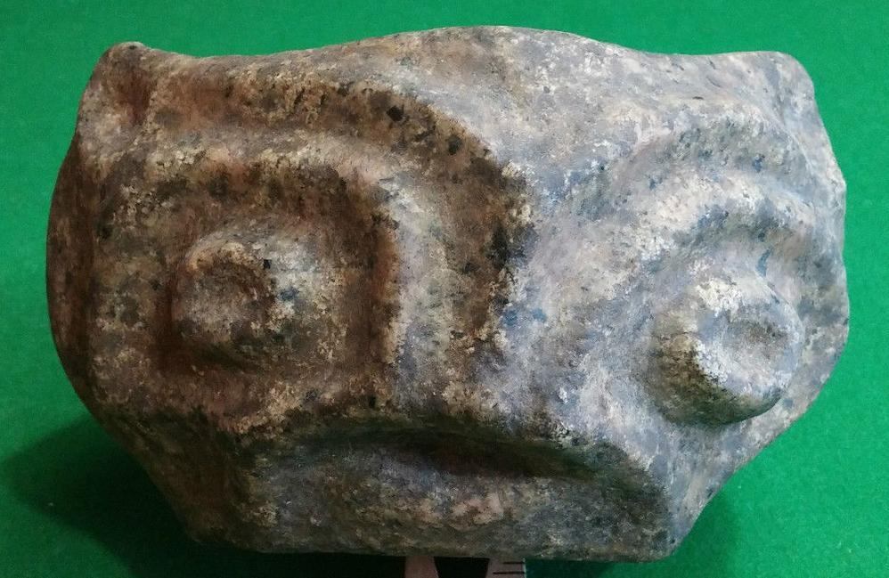 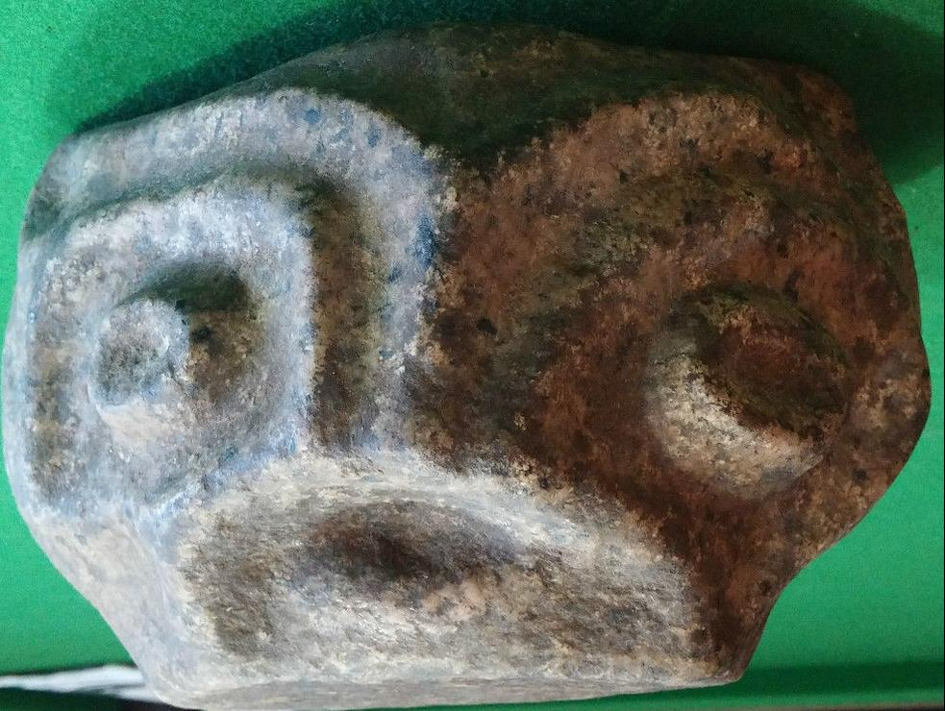

Fig. 1-2: Granite mortar Columbia River (Miocene) Basalt Group made this owl face of Tsagaglalal possible.

## 

## Fig. 3. Left. Edward S. Curtis, took this sepia tinted photograph of the **Tsagaglalal Petroglyph ca. 1910**, on finely grained Miocene basalt from what is now the Columbia Hills State Park - Horsethief Lake Petroglyphs, Eastern Gorge, Washington State.

## Fig. 4. Right. Without the sepia tint. A very faint red tinge to the image is the result of having been sprinkled with red ochre by People of the First Nations in a revivifying ceremony and not the result of a pictograph being placed over the abraded-style **Tsagaglalal Petroglyph**.

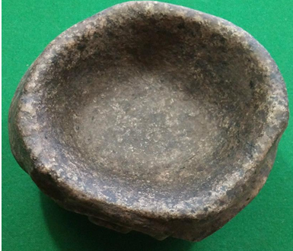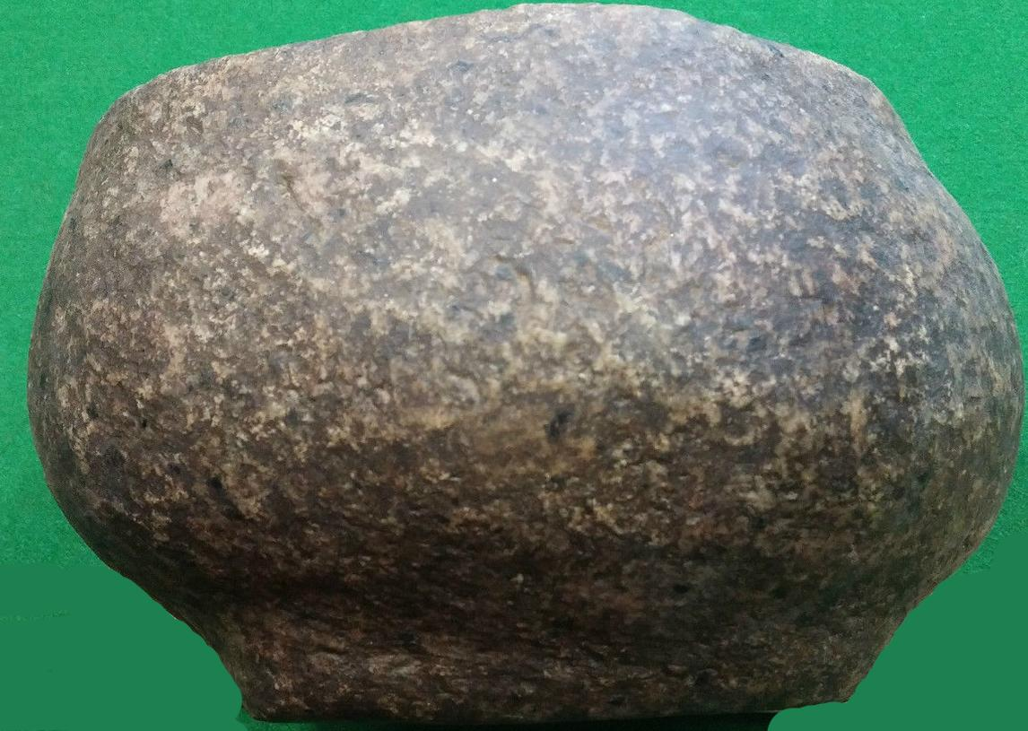

Fig. 5-6: Columbia River Granite mortar, from above and from the side.

Case no.: 8

Accession Number: A497

Formal Label: NW-Washington-Columbia River-Granite Mortar-Tsagaglalal-She Who Watches-pre 1800

**Display Description:**

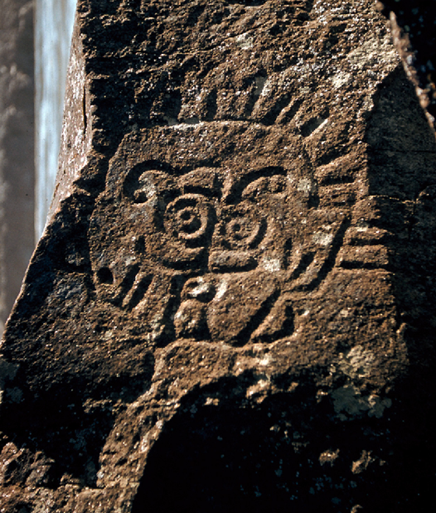 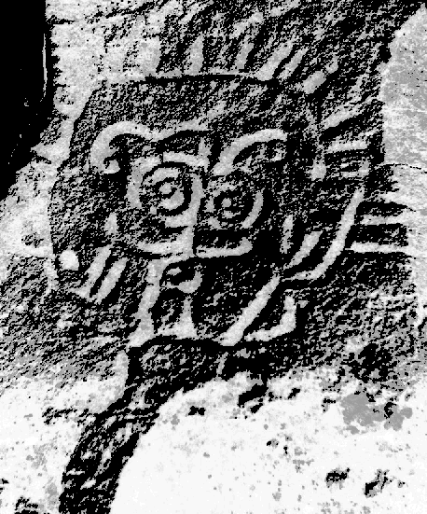

Fig. 7. Petroglyph of a bipedal spirit on vesicular basalt with uplifting arms and accentuated, round owl-eyes all enclosed in a radiant aura. This pre-1956 official photo U.S. Army Corps. of Engineers is turned 90 degrees to the right showing the Columbia River.

Fig. 8. Its desaturated inverted version better reveals the bipedal figure, which may be Tsagaglalalbefore Raven turned her into a petroglyph.

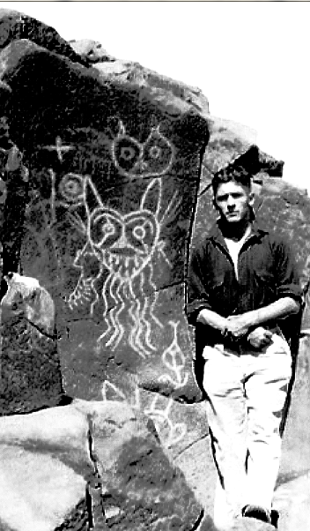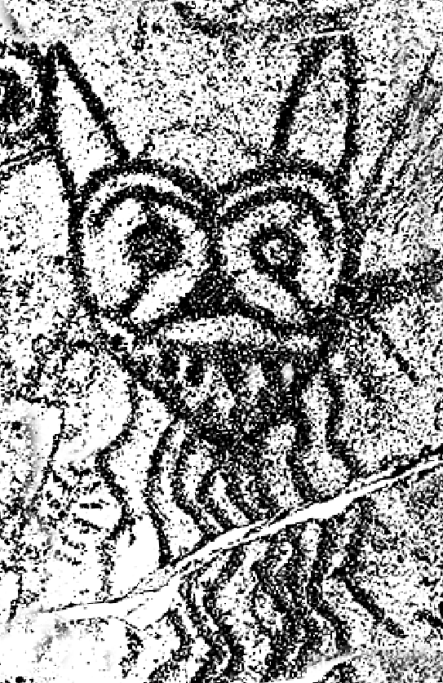

Fig. 9. Left. A pre-1956 photo of the watchful eye of a glowering River Spirit and owl-face Tsagaglalal above her. These petroglyphs have been chaulked to bring out the images, a practice now frowned upon because it abrades the petroglyph and obscures its coloration.

Fig. 10. Right. A later recording of the same petroglyph from its 2004 placement at Hosethief Park below.

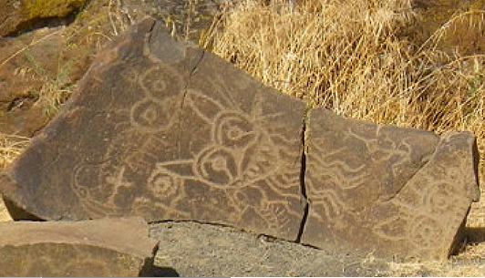

Fig. 11. The same petroglyph panel today removed to Horsethief Park and having fallen is split into two pieces. Note that the River Spirit is visually similar in lightness and therefore age to the second image of a River Spirit below. Above the main River Spirit is an image of owl-faced Tsagaglalal. From http://s379431721.initial-website.com/s/cc_images/cache_2839128104.jpg?t=1315636628

Vandalism occurred with spray paint in 2011. A commendable recovery in 2012 with laser paint removal techniques has reclaimed some affected boulders, but the incident has removed the petroglyphs from the path of foot travel they had previously enjoyed and all petroglyphs are now behind a protective fence that prohibits close inspection and limits photography.

**LC Classification:** E98.P6

Date or Time Horizon: pre-1800

Geographical Area: from the area of The Dalles **(**French: [*dalle*](https://en.wiktionary.org/wiki/dalle), “slab”, Gibson 1997: 125; Mc Arthur and McArthur 1996: 826). Referring to the Miocene columnar basalt rocks on the Columbia River created by the cooling of a thick lava flow, in which columns formed as a random cellular network, that are predominantly hexagonal in cross-section (Weaire and Rivier 2006).

**Map, GPS Coordinates:** 43.639677, 181.105005

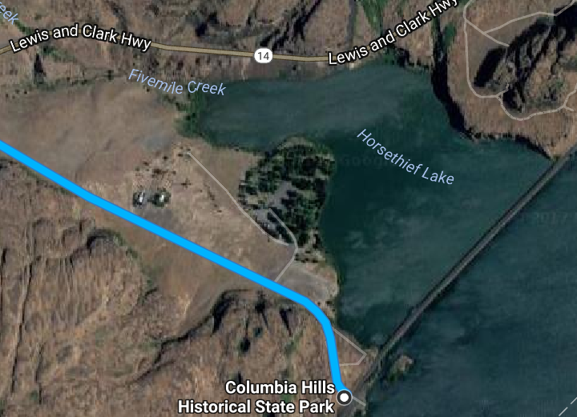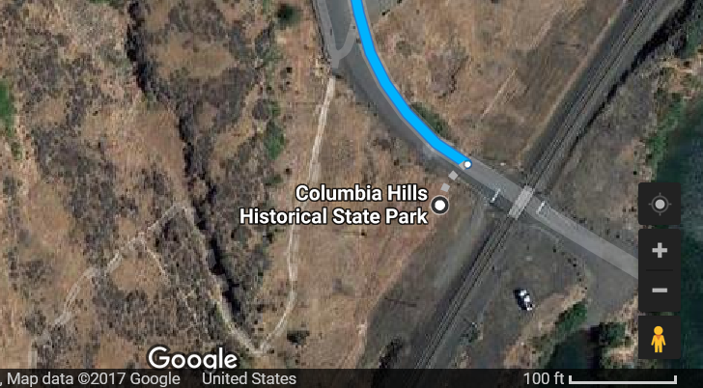

Fig. 7. Map of site from Google.com

Cultural Affiliation: Wishram?

Medium: Miocene Basalt, Columbia River Basalt Group (CRBG), 17 Ma

Dimensions: H 112.97 mm, 4.45 in; W 177.41 mm, 6.98 inWeight: 3,613 gm; 7 lb,15 3/8 oz

Provenance: Wishram area, Washington.

**Condition:** original**.**

**Discussion:**

1. The legend of Tsagaglalal. From Pitt 2016.

"There was this [Wishram] village on the Washington side of the Columbia Gorge. And this was long ago when people were not yet real people, and that is when we could talk to the animals. And so Coyote — the Trickster — came down the river to the village and asked the people if they were living well. And they said "Yes, we are, but you need to talk to our chief, **Tsagaglalal**. She lives up in the hill." So Coyote pranced up the hill and asked **Tsagaglalal** if she was a good chief or one of those evildoers. She said, "No, my people live well. We have lots of salmon, venison, berries, roots, good houses. Why do you ask?" And Coyote said, "Changes are going to happen. How will you watch over your people?" And so she didn't know. And it was at that time that Coyote changed her into a rock to watch her people forever."

1. The legend of Tsagaglalal. From Saynich 2015.

A woman was chief of all who lived in this region. That was a long time before Coyote came up the river and changed things, and the people were not yet real people. After a time, Coyote, in his travels came to this place and asked the inhabitants if they were living well or ill. They sent him to their chief who lived up in the rocks, where she could look down on the village and know what was going on. Coyote climbed up to the house on the rocks and asked, “What kind of living do you give these people? Do you treat them well or are you one of those evil women?” “I am teaching them to live well and build good houses,” she said. When she expressed her desire to be able to do this forever, he said, “Soon the world will change and women will no longer be chiefs.” Being the trickster that he was, Coyote changed her into a rock with the command, “You shall stay here and watch over the people and the river forever.”

1. Moulton 1983: 331-332. [Clark] October 24th Thursday 1805.

The whole of the Current of this great river must at all Stages pass thro' this narrow chanel of 45 yards wide. as the portage of our canoes over this high rock would be impossible with our Strength, and the only danger in passing thro those narrows was the whorls and Swills arriseing from the Compression of the water, and which I thought (as also our principal watermen Peter Crusat) by good Stearing we could pass down Safe, accordingly I deturmined to pass through this place notwithstanding the horrid appearance of this agitated gut Swelling, boiling & whorling in every direction (which from the top of the rock did not appear as bad as when I was in it;) however we passed Safe to the astonishment of all the Inds: of the last Lodges who viewed us from the top of the rock [this high rock became Browns Island when the waters of Lake Celilo inundated the valley]. passed one Lodge below this rock and halted on the Star[boa]d. Side to view a verry bad place, the Current divided by 2 Islands of rocks the lower of them large and in the middle of the river, this place being verry bad I Sent by land all the men who could not Swim and Such articles as was most valuable to us Such as papers Guns & amunition, and **proceeded down with the Canoes two at a time to a [Wishram] village of 20 wood houses in a Deep bend to the Star[boar]d. Side [area of Horsethief Butte and Horsethief Lake] below which a rugid black rock about <the> 20 feet hier <of> than the Common high fluds of the river with Several dry Chanels which appeared to Choke the river up quite across; this I took to be the 2d falls or the place the nativs above call *timm*.** The nativs of this village re[ce]ived me verry kindly, one of whome envited me into his house, **...**    I dispatched a Sufficent number of the good Swimers back for the 2 canoes above the last rapid and with 2 men walked down three miles to examine the river Over a bed of rocks, which the water at verry high fluds passes over, on those rocks I Saw Several large Scaffols on which the Indians dry fish; as this is out of Season the poles on which they dry those fish are tied up verry Securely in large bundles and put upon the Scaffolds, I counted 107 <Scaff> Stacks of dried pounded fish in different places on those rocks which must have contained 10,000 w. of neet fish,

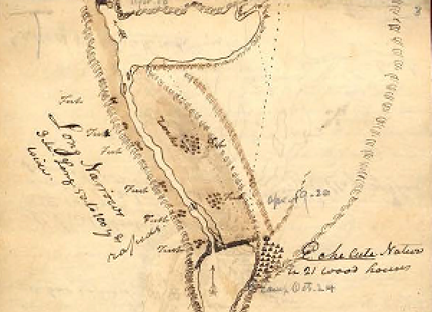

Map of the Wishram village of “21 wood houses” Codex H, No. 2, p. 3, “A Sketch of the Long & Short, Narrows of the Columbia River,” Oct. 22-28, 1805, by Captain James Clark, American Philosophical Society, graphics 2628.

1. **Petroglyphs**

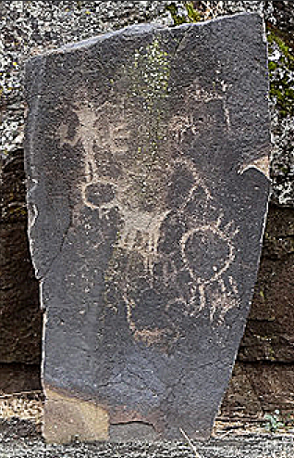 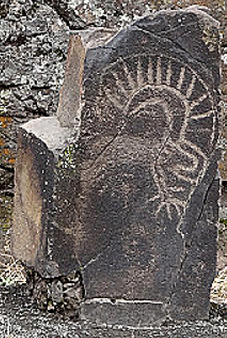

From <http://columbiariverimages.com/Images11/horsethief_lake_park_petroglyphs_10-15-11.jpg>

These petroglyph panels on Miocene basalt from the Columbia Hills State Park with older petroglyphs effaced beneath much newer ones of Tsagaglalal. The one on the left may recount (in a newer petroglyph) the myth of coyote (the four-legged animal in photo) making Tsagaglalal (the anthropomorph with both hands akimbo) into a petroglyph (circle to the lower right with the radiating aura, Tsagaglalal’s symbol for radiating energy). The one on the right shows what appears to be a side view of Tsagaglalal with her radiating aura.

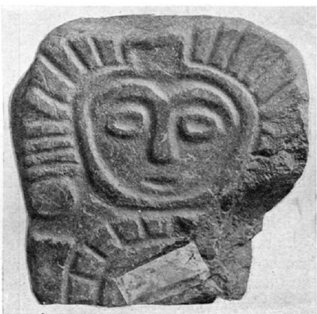

1. Stone statuette (possibly of Tsagaglalal) with a radiating aura from near Lyle, Washington. Photo, courtesy of B. C. Markham, Lyle, Washington. Before 1970.
2. **Geology**

"Flood basalts of the Miocene Columbia River Basalt Group (CRBG) are among the most voluminous and far-traveled lava flows on earth. About 10% of the basalt flows that erupted on the Columbia Plateau between 17 and 12 Ma were voluminous enough to pass through the Cascade arc via a wide ancestral Columbia River valley, and some of them eventually reached the Pacific Ocean” (Wells, Niem, Evarts, and Hagstrum 2009).

**References:**

Boas, Franz. 1893. “Doctrine of Soul and Disease among the Chinook,” *Journal of American Folklore* 6:39-43.

Boas, Franz. 1894. *Chinook* *Texts*. Bureau of American Ethnology Bulletin 20. Washington, D.C.

Boas, Franz. 1901. *Kathlamet Texts*. Bureau American of Ethnology Bulletin 26. Washington, D.C.

Boas, Franz. 1933. "Notes on the Chinook Jargon," *Language* 9:208-13.

Cressman, Luther S. 1960. *Cultural Sequences at The Dalles, Oregon.* Philadelphia: American Philosophical Society.

Curtis, Edward. 1910. *The North American Indian*, 8:85-154, 172-83, 198-205.

French, David.1961. *"Wasco-Wishram."* In Edward H. Spicer, ed., *Perspectives in American Indian Cultural Change*, pp. 337-430. Chicago: Univ. of Chicago Press.

Gibbs, George. 1955-6. "Account of Indian Mythology of Oregon and Washington Territory," *Oregon Historical Quarterly*, 56(4):293-325, 57(2):125-67.

——. 1970 [1863]. *Alphabetical Vocabulary of the Chinook Language*. New York: Cramoisy Press. Reprinted by AMS Press. Sabin Americana, 2012.

——. 1863. *A Dictionary of the Chinook Jargon, or Trade Language of Oregon*. Washington, D.C.: Smithsonian Institution.

——. 1857. “Observations of the Coast Tribes of Oregon.” Ms. 196-a. Washington, D.C.: National Anthropological Archives.

——. 1877. “Tribes of Western Washington and Northwestern Oregon,” *Contributions to North American Ethnology*, 1: 157-361. [In US Geographic and Geological Survey of the Rocky Mountain Region.]

—— and Edmund. A. Starling. 1851 [?]. Sketch of the Wallemette [sic] Valley: Showing the Purchases and Reservations Made by the Board of Commissioners, Appointed to Treat with the Indians of Oregon, April and May [s.l.].

——. 1970 [1877]. William. F. Tolmie and Gregory Mengarini. Comparative Vocabularies of the Tribes of Western Washington & Northwestern Oregon. Seattle: Shorey. Extract from Vol. 1 of Contributions to American Ethnology, Washington, DC.

——, —— and ——. 1970 [1877]. *Tribes of Western Washington & Northwestern Oregon*. Seattle: Shorey Book Store. Originally published: Washington, D.C.: U.S. Govt. Print. Off. Contributions to North American

Ethnology; vol. 1, pt. 2.

Gibson, James R. 1997. The Lifeline of the Oregon Country: The Fraser-Columbia Brigade System, 1811–47. University of British Columbia Press.

Jacobs, Melville. 1955. "A Few Observations on the World View of Clackamas Chinook Indians," *Journal of American Folklore* 68:283-89.

Jacobs, Melville. 1958. *Clackamas Chinook Texts*. Bloomington: Univ. of Indiana.

Kane, Paul. 1971. *Paul Kane's Frontier*. Austin, Texas: J. Russell Harper.

____. 1971. *Columbia Wanderer.* Ed. Thomas Vaughan. Portland, Oregon: Oregon Historical Society Press.

McArthur, Lewis A.; McArthur, Lewis L. 1992. [1928]. Oregon Geographic Names (6th ed.). Portland, Oregon: Oregon Historical Society Press.

Moulton, Gary E. 1983. [1805]. *The Journals of Lewis and Clark*. Lincoln and London: University of Nebraska Press, pp. 331-32. [Clark] October 24th Thursday, 1805.

Pitt, Lillain. 2016. “Pacific Northwest Native American Artist.” From lillianpitt.com.

Rubin, Rick. 1981. "Coyote on the Columbia." In *The Northwest Experience* 2:166-79. Seattle: Madrona Publishers.

____. 1986. *"She Who Watches."* *Northwest Magazine*, (Portland, Sept. 28).

____. 1999. *Naked Against the Rain: The People of the Lower Columbia River.* Portland: Far Shore Press.

Sapir, Edward. 1909. *Wishram Texts.* American Ethnological Society.

Sapir, Edward and Leslie Spier. 1930. *Wishram Ethnography*. Seattle: Univ. of Washington Press.

# Saynich, Carol. 2015. “The Legend of Tsagaglalal (She Who Watches).” From [**http://www.gatheringthestories.org/2013/10/26/the-legend-of-tsagaglalal-she-who-watches/**](http://www.gatheringthestories.org/2013/10/26/the-legend-of-tsagaglalal-she-who-watches/). Accessed 2017 Oct. 23.

Silverstein, Michael. 1990. *"Chinookans of the Lower Columbia."* In *Handbook of North American Indians*, 7:533-46.

Smith, Marian W. 1943. "Columbia Valley Art Style," *American Antiquity* (ns) 45:158-60.

Smith, Marian W. 1949. "Basketry Design and the Columbia Valley Art Style," *South-Western Journal of Archeology* 8:336ff.

Strong, W. Duncan. 1945. “The Occurrence and Wider Implications of a 'Ghost Cult' on the Columbia River Suggested by Carvings in Wood, Bone and Stone,” *American Antiquity* 47:244-261.

Strong, W. Duncan, and Julian Steward. 1930. *Archaeology of the Dalles-Deschutes Region*. University of California Publications, American Archaeology and Ethnology, no. 29.

Steward, Julian. 1927. “A New Type of Carving from the Columbia Valley,” *American Anthropologist*, n.s., 29: No. 2, 255-261.

Weaire, D. and N. Rivier. 2006. "Soap, cells and statistics—random patterns in two dimensions," Contemporary Physics, **25** (1): 59–99.

Wells, R.E., A.R. Niem, R. C. Evarts, and J. T. Hagstrum. 2009, "The Columbia River Basalt Group -- From the gorge to the sea." In Jim E. O’Connor, Rebecca J. Dorsey and Ian P. Madin, eds., *Volcanoes to Vineyards: Geologic Field Trips through the Dynamic Landscape of the Pacific Northwest*, Geologic Society of America Field Guide, 15, pp.737-774.